C++ "TAX TABLE LOOKUP" Lab Report

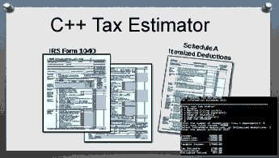
1) Enter your name, student ID and date
Name: Jay Gupta
Student ID: 0961979
Platform (Mac or PC): PC
Date: 3/24/2020

PROJECT DESCRIPTION:
When people fill out their tax return, they have the option of itemizing their deductions or using a standard deduction. If people are buying a house and have a mortgage, have donated a lot of money to charities, have high medical bills or other deductions, it may be better to itemize and list all their deductions. For many people it may be better to take the 'standard deduction'

The program should ask for the following information in this order:
When all the data has been collected, the program displays
Most of the code for the Tax Estimator project has already been completed. The program needs to be updated to ask if the user wants to itemize or use the standard deduction.
a) Tax status - single, married filing jointly, etc.
b) Number of exemptions (people you can claim on your taxes 1, 2, 3, etc.)
c) Total income in dollars
d) Select either standard deduction or itemized deduction
1. If the standard deduction is selected, the amount is to be looked up from an array. The array is to
filled with the data shown in the table below.
2. If the itemized deduction is selected, the dollar amount of the deduction is to be read from the
keyboard.
e) Amount withheld in dollars (usually from the W2 from your employer)
a) Income in dollars (not all of your income is taxable)
b) - Exemption in dollars (based on the number of people being supported, including yourself)
c) - Deductions in dollars (standard deduction, or mortgage, donations, some medical bills, etc.)
d) = Taxable income
e) Computed tax in dollars (from the tax tables)
f) - Amount withheld in dollars (usually shown on the W2 from your employer)
g) = Refund or amount owed in dollars

1) If the user selects itemize, then the program is to ask for the amount of the itemized deduction. ✔

2) If the user selects standard deduction, then the program looks up the amount of the deduction from an array, based on the filing status (single, married, etc.). You need to create the array and the code to lookup the amount of the deduction from the array. The array is to be filled with the following data: ✔
Taxpayer Status Standard Deduction
=========================================
Single 6300.00
Married filing jointly 12600.00
Married filing separately 6300.00
Head of Household 9250.00
Qualifying Widow(er) 12600.00

SAMPLE PROGRAM EXECUTIONS:
After you have updated the program to include the standard deductions, verify that you get the same results as shown in the sample execution. Then come up with your own values (not the same as the sample values) and fill in the TEST VALUES & RESULTS table below.
FEDERAL TAX ESTIMATOR
The data in this project is from a previous tax year. Tax tables
are adjusted each year due to inflation and legal changes. The
output from this program is for information purposes only.

==================================================
Enter your tax status:
1 = Single
2 = Married filing jointly
3 = Married filing separately
4 = Head of Household
5 = Qualifying widow(er)
0 = END THE PROGRAM
> 1
Enter the number of exemptions: (you + dependents): 2
Enter your total income: 40000
Select 1=Itemized Deductions, or 2=Standard Deductions: 1
Enter the amount of your Itemized Deductions: 1500
Enter the amount withheld: 3587

Income: 40000.00
Exemptions: -8000.00
Deductions: -1500.00
--------------------------
Taxable Income: 30500.00

Tax Estimate: 4113.75
Withholding: 3587.00
Please pay: 526.75

==================================================
Enter your tax status:
1 = Single
2 = Married filing jointly
3 = Married filing separately
4 = Head of Household
5 = Qualifying widow(er)
0 = END THE PROGRAM
> 1
Enter the number of exemptions: (you + dependents): 2
Enter your total income: 40000
Select 1=Itemized Deductions, or 2=Standard Deductions: 2
Enter the amount withheld: 3587

Income: 40000.00
Exemptions: -8000.00
Deductions: -6300.00
--------------------------
Taxable Income: 25700.00

Tax Estimate: 3393.75
Withholding: 3587.00
Estimated refund: 193.25

Itemized Deduction

Standard Deduction

LAB REPORT:
2) Fill in the TEST VALUES & RESULTS table
Choose an income between $10,000 and $80,000 (don't enter the $ when running the program)
Compute the Expected Results using a calculator.
Fill in the Actual Results after you have run and tested your program
INCOME | FILING  STATUS | DEDUCTION SELECTION | EXPECTED RESULTS | ACTUAL RESULTS
$75,000 | Single | Standard | Taxable Income: 60700.00  Tax Estimate: 10968.75  Withholding: 1500.00  Please pay: 9468.75 | Taxable Income: 60700.00  Tax Estimate: 10968.75  Withholding: 1500.00  Please pay: 9468.75
$54,500 | Married  filing jointly | Standard | Taxable Income: 33900.00  Tax Estimate: 4162.50  Withholding: 2598.00  Please pay: 1564.50 | Taxable Income: 33900.00  Tax Estimate: 4162.50  Withholding: 2598.00  Please pay: 1564.50
$69,870 | Head of Household | Standard | Taxable Income: 52620.00  Tax Estimate: 7477.50  Withholding: 4017.00  Please pay: 3460.50 | Taxable Income: 52620.00  Tax Estimate: 7477.50  Withholding: 4017.00  Please pay: 3460.50
$39,470 | Single | Itemized = 3400 | Taxable Income: 28070.00  Tax Estimate: 3749.25  Withholding: 2090.00  Please pay: 1659.25 | Taxable Income: 28070.00  Tax Estimate: 3749.25  Withholding: 2090.00  Please pay: 1659.25

DISCUSSION:
3) Complete the DISCUSSION section in English. It does not need to be long, but it needs to be complete.
3a) What did you do to develop the program?

This was my first experience with taxes, and I wanted to get a sense of what I was doing. After watching your video, I looked up on Google about taxes and how they work. After that, I saw the project requirements and analyzed what it is that was being asked for me to do. I used the function that hadn’t been defined, and created it. Since this topic was very complex, I kept on running the program to make sure that everything was working fine.

3b) What problems did you have and how did you overcome the problems?

I accidentally declared deductions twice, and at the same time, I hadn’t initialized the version of deductions that was being used. As a result, I was getting very high numbers for deductions. To solve this error, I debugged my code by adding ‘cout’ statements in various places, trying to see where the error occurred. I saw that the error occurred as soon as I left the else if block, and realized I had declared the variable twice.

PROGRAM OUTPUT:
4) Show four screenshots of the program when it is running. Refer to previous lab assignments on how to capture a screen shot and paste it into the lab report.
Filing Status = Single
Deduction Selection = Standard

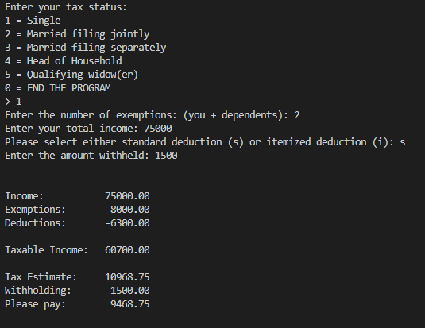
Filing Status = Head of Household
Deduction Selection = Standard
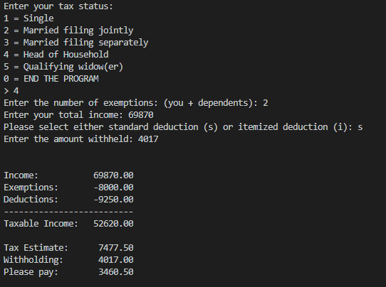

Filing Status = Married filing jointly
Deduction Selection = Standard

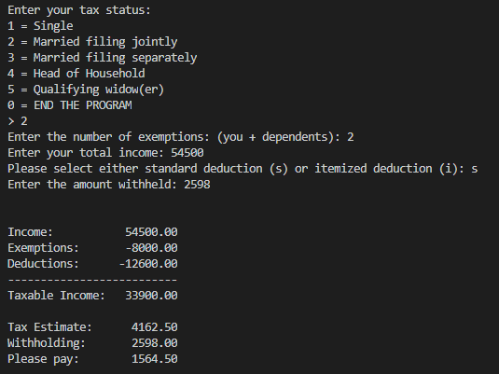
Filing Status = Single
Deduction Selection = Itemized at 3400
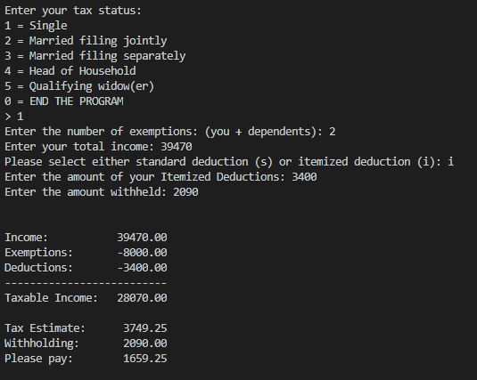

PROGRAM LISTING:
5) Copy and paste ONLY the code that you wrote to implement the choice of standard deduction.
double inputDeductions(int taxpayerStatus)
{
char typeOfDeduction;
// ask user to select either standard deduction or itemized deduction
do {
cout << "Please select either standard deduction (s) or itemized deduction (i): ";
cin >> typeOfDeduction;
} while (typeOfDeduction != 'i' && typeOfDeduction != 'I' && typeOfDeduction != 's' && typeOfDeduction != 'S');

double deductions = 0;
if (typeOfDeduction == 'i' || typeOfDeduction == 'I') {
cout << "Enter the amount of your Itemized Deductions: ";
cin >> deductions;
} else if (typeOfDeduction == 's' || typeOfDeduction == 'S') {
deductions = standardDeduction(taxpayerStatus - 1);
}
return deductions;
}

double standardDeduction(int index) {
double standardDeductions [5] = {6300.00, 12600.00, 6300.00, 9250.00, 12600.00};
return standardDeductions[index];
}

